**USER MANUAL**

**CLUB MANAGER**



*Prepared By: Khaya Ngema*

Table of Contents

Purpose of this document 2

SECTION 01 3

How to access your club information, players, matches, and standings? 3

SECTION 02 9

How to access club fixtures? 9

SECTION 03 10

How to set lineup for a scheduled match? 10

SECTION 04 21

How to set match formation? 21

SECTION 05 23

How to access your club match results? 23

SECTION 06 24

How to reports? 24

## Purpose of this document

The purpose of this user manual is to provide a clear and detailed guide for users of the **Sports Management System**, enabling them to efficiently manage and operate all aspects of the system. It is designed to:

1. **Simplify Operations:** Provide step-by-step instructions for managing schedules, fixtures, teams, players, and other system features.
2. **Enhance Efficiency:** Ensure users can utilize the system effectively to save time and streamline sports management tasks.
3. **Ensure Accuracy:** Reduce errors in managing data and processes through clear guidance.
4. **Promote Accessibility:** Make the system easy to use for both novice and experienced users.
5. **Reduce Support Dependency:** Empower users to troubleshoot and resolve common issues independently.

**Intent of the User Manual**

The intent of this user manual is to serve as a reliable and user-friendly resource that helps users:

1. **Understand the Sports Management System:**
   * Learn about its features, capabilities, and benefits for managing sports activities.
2. **Perform Key Tasks:**
   * Navigate the system to manage fixtures, team schedules, player data, and results with ease.
3. **Troubleshoot and Resolve Issues:**
   * Identify and address common challenges without external support.
4. **Ensure Seamless Usage:**
   * Reduce confusion by providing clear and concise instructions for each feature.
5. **Optimize System Usage:**
   * Maximize the potential of the system to support effective decision-making and efficient sports management.

### SECTION 01



## How to access your club information, players, matches, and standings?

Step 1: After you have successfully logged into the system, find a tab or pane namely “My club”. Click the “Club” button within this pane.

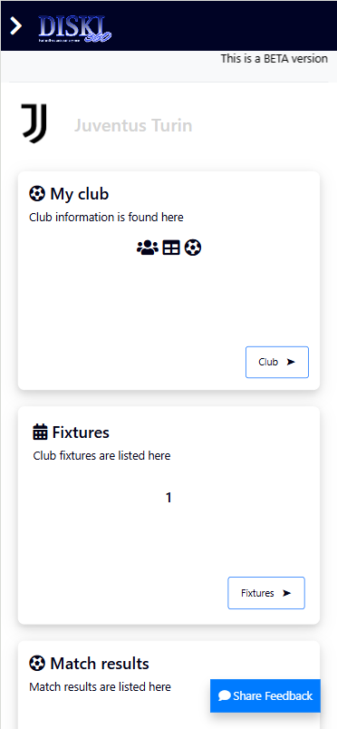



Step 2: You will be redirected to this page (See image below) where your club is displayed, and a little summary is shown. Click the “Details” button at the bottom right of the page.

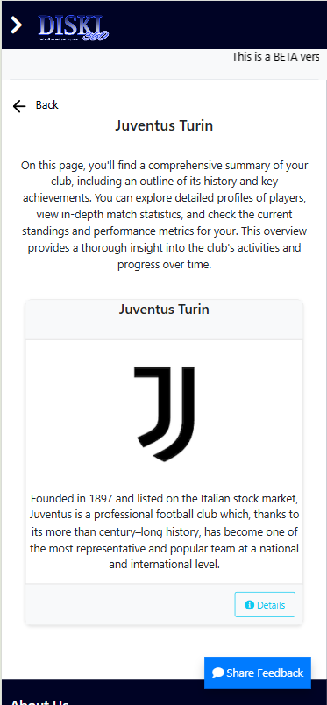



Step 3: How to see your club summary?

You will be redirected to this page (See image below) where your club information is separated in tabs as follows:

**Summary:** This is the detailed club manager, summary, and history. (Refer to step 3.1)

**Players:** This is a comprehensive list of your club players (Refer to step 3.2)

**Matches:** These are all matches your club has participated in. (Refer to step 3.3)

**Table:** This is the highlight of your club standings in the current season. (Refer to step 3.4)

Step 3.1: To see your club summary, click the “Summary” tab.

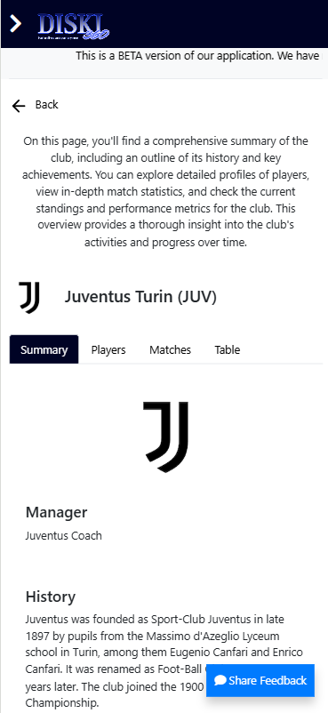



Step 3.2: How to see your club players?

To see your club players, click the “Players” tab and the system will display a comprehensive list of your club players. If you want to see each player’s details, you can click on that specific player’s row, and you will see the player profile detailing their information and statistics. (Refer to Figure 2 below)

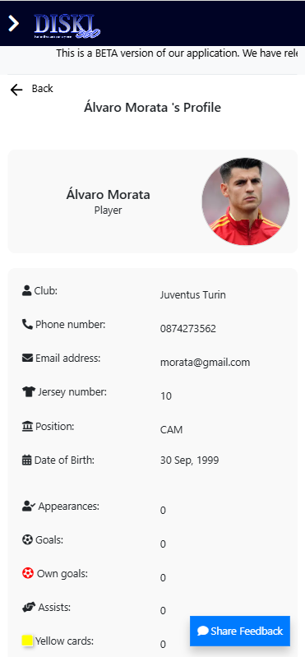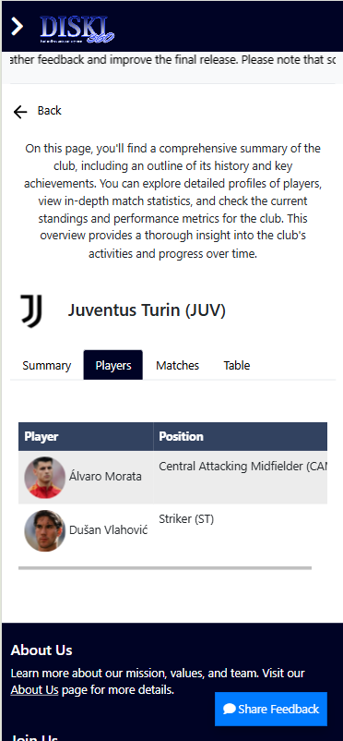



*Figure 1 Figure 2*

Step 3.3: To see your club matches, click the “Matches” tab and you will see a list of all matches you club have participated on with the most recent matches at the top.

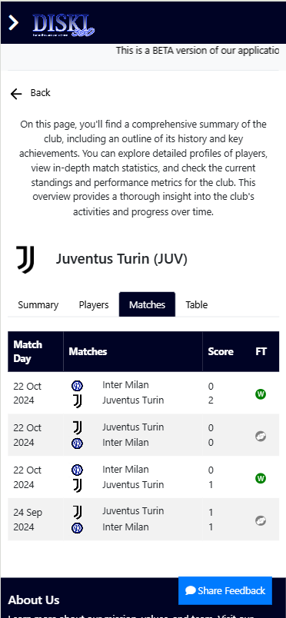



Step 3.4: To see your club standings on the standings table, click the “Table” tab and you will see the current season’s log table with your club highlighted in grey. (See image below).

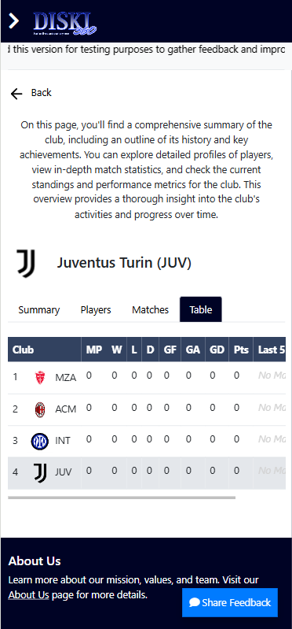



### SECTION 02



## How to access club fixtures?

Step 1: After you have successfully logged into the system, find a tab or pane namely “Fixtures”. If your club is scheduled for any upcoming matches, you will see “1” withing this tab (Refer to Figure 1 below). Click the “Fixtures” button within this pane to see the fixture details.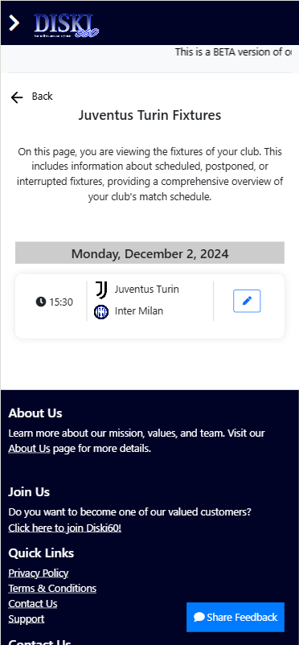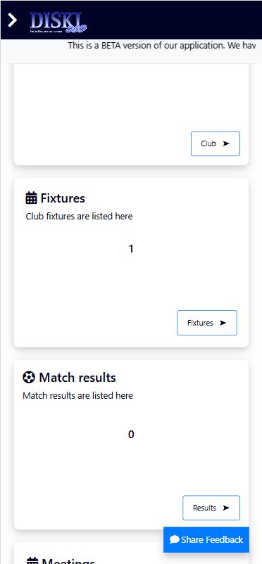



*Figure 1 Figure 2*

NOTE: Now you have successfully accessed your club fixture, and it details. (Refer to Figure 2 above).

### SECTION 03



## How to set lineup for a scheduled match?

Step 1: After you have successfully logged into the system, find a tab or pane namely “Fixtures”. Click the “Fixtures” button.





Step 2: You will be redirected to this page (see image below) which displays your club scheduled match and its details. Click the “Pen” icon or button.





Step 3: You will be redirected to this page (see image below) which displays your club scheduled match lineup. Initially when you arrive in this page, there will ne no lineup set since you haven’t set any. (See image below).

WARNING: You can only set a match lineup if the remaining time before Kick-off is below or equal to 1 hour or it is minutes after kick-off (This does not mean that you can set a lineup if the match is up and running).

To set a lineup Click “Set line-up” button at the bottom right of the screen.

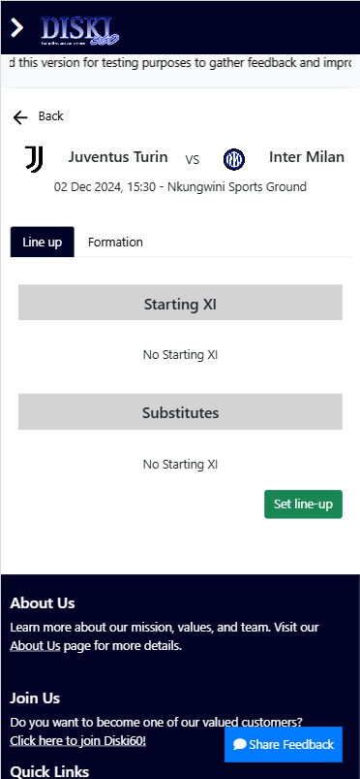



Step 4: This page will be displayed (See image below) where you can search your club players and add them into the lineup starting XI or substitutes. In the search bar, type in the name of the player you would like to add to either lineup starting XII or substitutes.

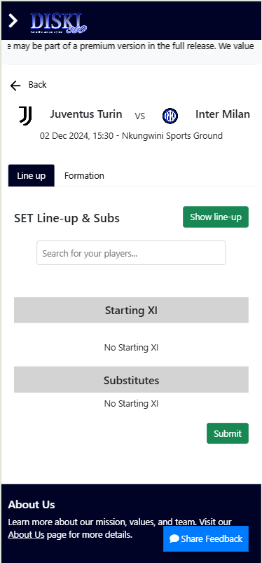



Step 4: The player with the matching name or last name as your input will appear on the screen (See image below).

How to add a player to:

**Starting XI:** (Refer to step 4.1 below)

**Substitutes**: (Refer to step 4.2 below)

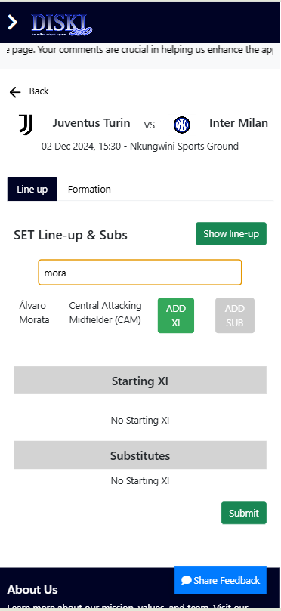



Step 4.1: How to add a player to Starting XI?

After the player you were searching has appeared on the screen, Click the “ADD XI” button next to the player’s name.

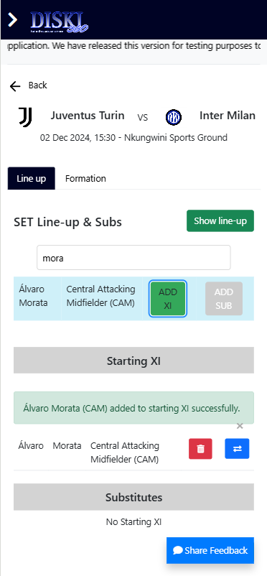



NOTE: Now you have successfully added your player in starting XI.

Step 4.2: How to add a player to substitutes?

After the player you were searching has appeared on the screen, Click the “ADD SUB” button next to the player’s name.

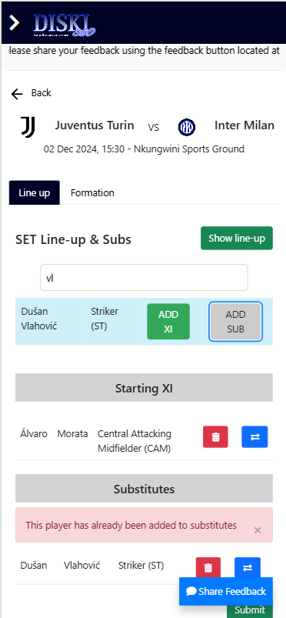



NOTE: Now you have successfully added your player in substitutes.

Step 5: How to move a player from substitutes to starting XI while editing the lineup?

Click the two opposing arrows next to the player under Substitutes.

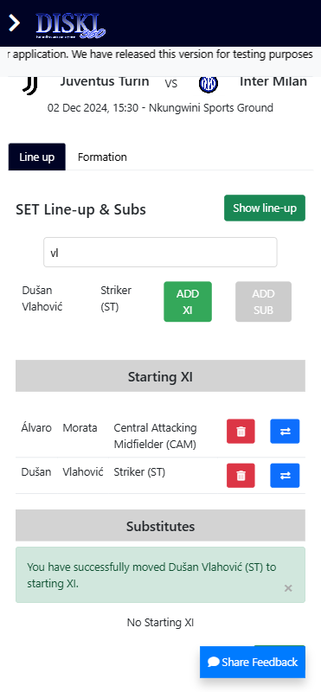



NOTE: Now you have successfully moved a player from substitutes to starting XI.

Step 6: How to move a player from Starting XI to substitutes while editing the lineup?

Click the two opposing arrows next to the player under Starting XI.

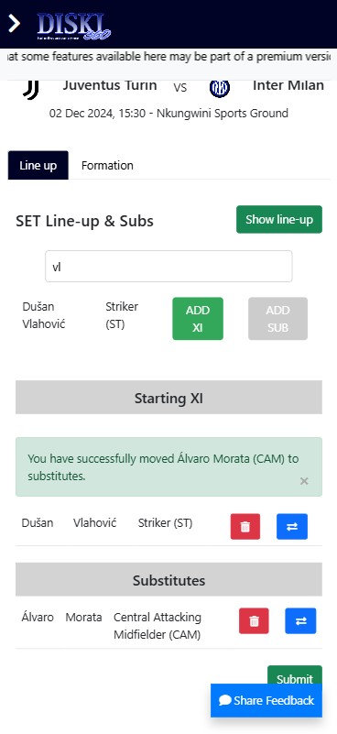



NOTE: Now you have successfully moved a player from Starting XI to substitutes.

Step 7: How to remove a player from either starting XI or substitutes?

Click the “Red Bin” icon or button next to the player you want to remove under Starting XI or substitutes.

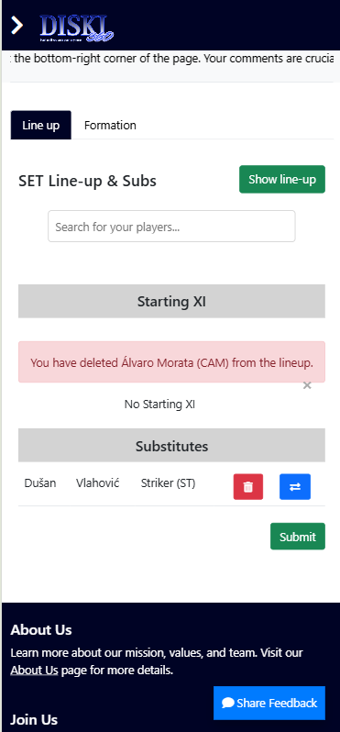



NOTE: Now you have removed a player from Starting XI or substitutes.

Step 4: Now you have added, edited, and removed your club players to lineup, and you are satisfied with the final lineup for your club scheduled match, Click the “Submit” button at the bottom right of the screen to set your final lineup that will be displayed.

WARNING: Once you submit your club’s lineup, you cannot edit or delete it again for that scheduled match.

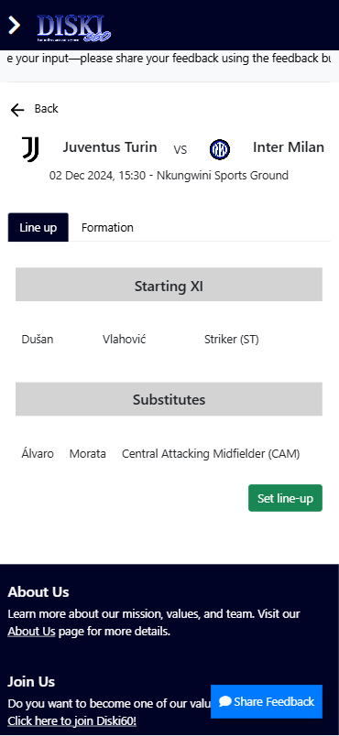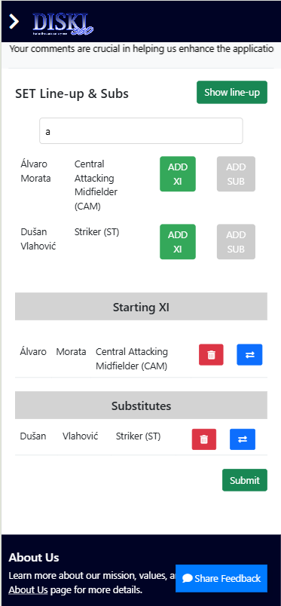



*Figure 1 Figure 2*

NOTE: Now you have successfully set your lineup and to view it, you can click the “Show line-up” button at the top right of the screen. (See Figure 1 and 2 above).

### SECTION 04



## How to set match formation?

### SECTION 05



## How to access your club match results?

Step 1: After you have successfully logged into the system, find a tab or pane namely “Match results”. The tab or pane shows a number (e.g. 1) which represents the number of your match results for the current season. Click the “Results” button.

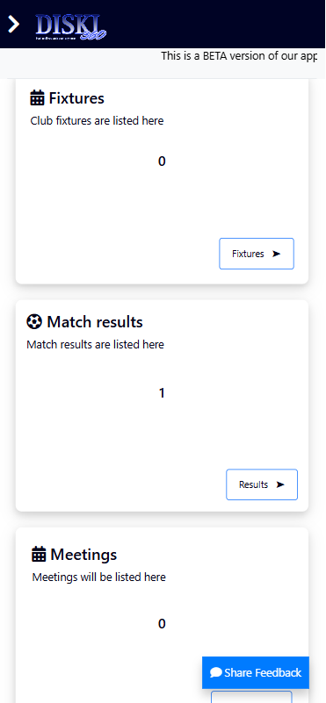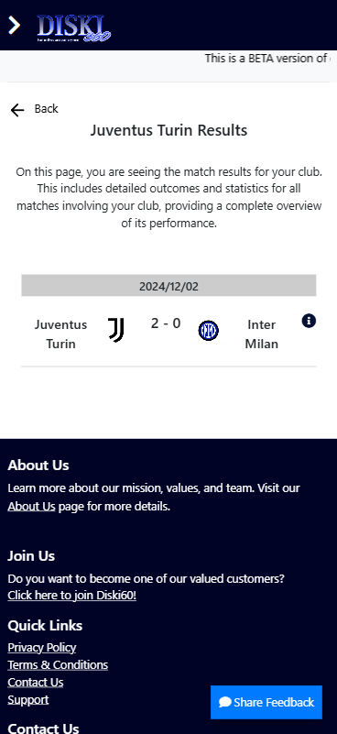



NOTE: Now you have successfully accessed your club’s match results.

### SECTION 06



## How to reports?

Step 1: After you have successfully logged into the system, while on the dashboard, click the “>” button at the top left of the screen to expand the navigation menu.

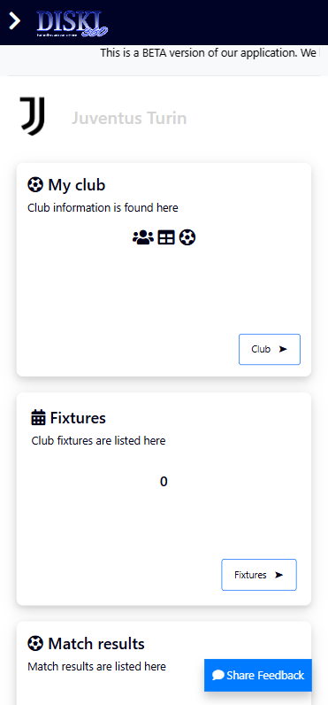



Step 2: On the navigation menu, find “Reports & Analytics” navigation link and click on it to see different reports you can access.

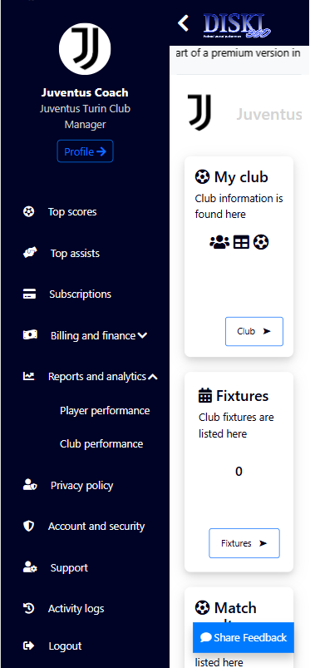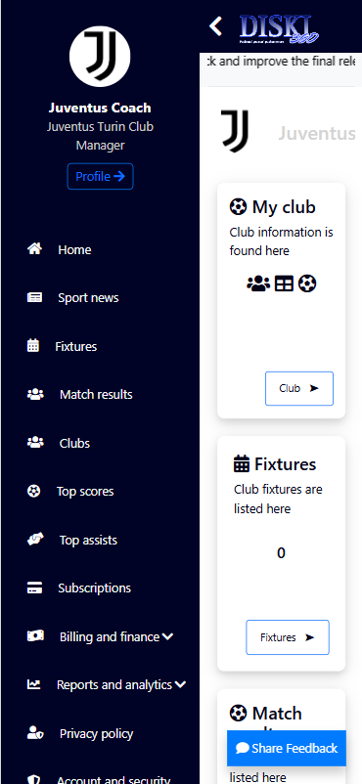



*Figure 1 Figure 2*

Step 3: If you want to access the player performance report, click “Player performance” and if you want to access club performance report, click “Club performance”.

Report types:

**Player performance report:** (Refer to figure 1 below)

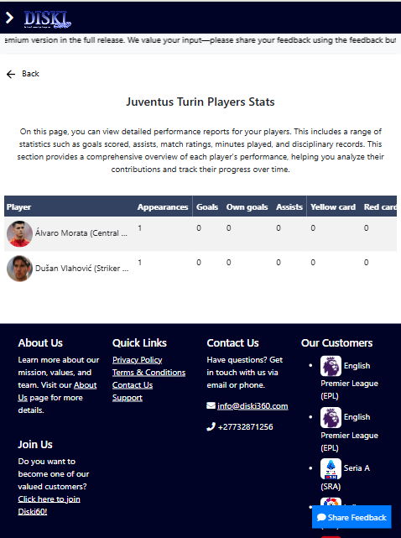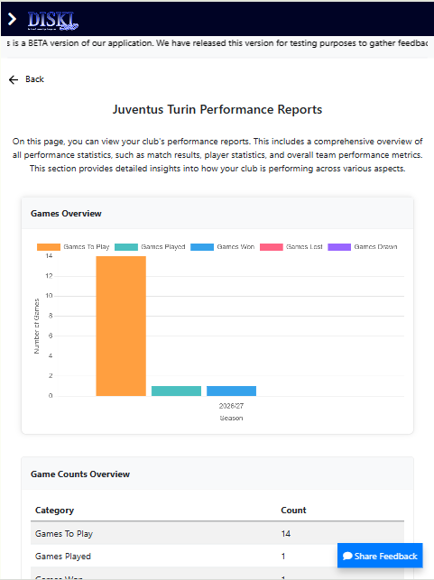**Club performance report:** (Refer to figure 2 below)



*Figure 1 Figure 2*